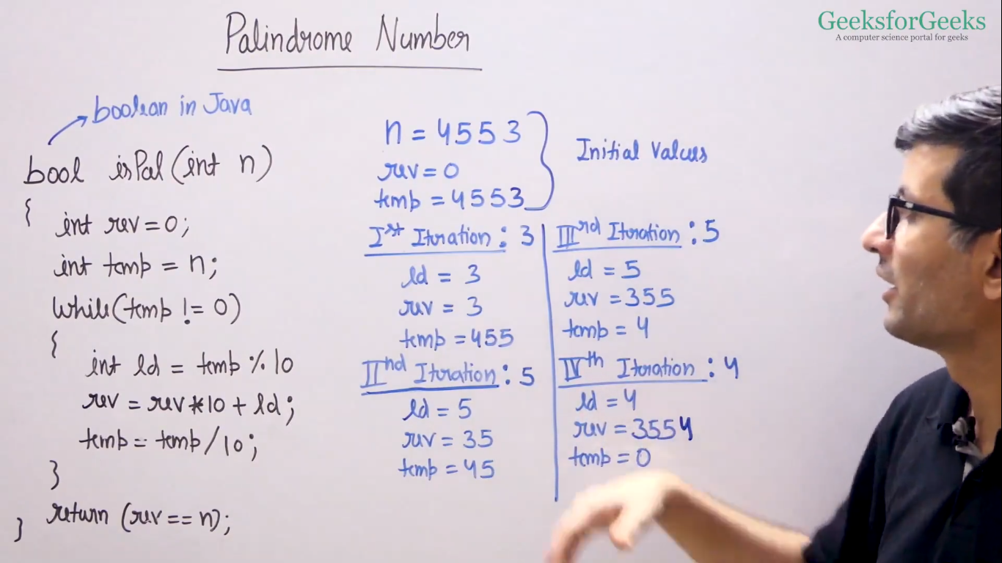

To find all the prime factor of product of array.

Approach 1: first find the product of all the elements of the array and then find its prime factor but this will give the integer overflow.

Approach 2: find all the prime factor of each element and put that in the set . so after all the computation we will have all the unique prime factors in the set.

To find the prime factor of a number .=> traverse from 2 to sqrt(num) if any of the i divides num and give mudulo 0. Then it is a factor after that we will divide num by i till we get num%i==0.

int distinctPrimeFactors(vector<int>& nums) {

        int n= nums.size();

        set<int>s;

        for(int i=0;i<n;i++){

            for(int j=2;j<=sqrt(nums[i]);j++){

                if((nums[i]%j)==0){

                    s.insert(j);

                    while(nums[i]%j==0){

                        nums[i]=nums[i]/j;

                    }

                }

            }

            if(nums[i]>1){

                s.insert(nums[i]);

            }

        }

        return s.size();

    }

